THE “DEVANAPIYA” KINGS AS TRACED FROM LITHIC ‘BRAHMI’ INSCRIPTIONS OF SRI LANKA
Inoka Damayanthi Manthilake,
University of Moratuwa,
Sri Lanka
imanthilake@uom.lk
Abstract
Inscriptions of Ceylon volume 1 by Prof. S. Paranavithana, presents a collection of over a thousand lithic inscriptions discovered in a series of archaeological surveys of Ceylon carried out from 1855 to 1970. These inscriptions are dated from 300 BC to 100 AD based on similar work found in India and the information from ancient palm leaf text from Sri Lanka. In these inscriptions a lineage of royal members called “Devanapiya” is recurring. However, a systematic study has not been carried out directly referring to this lineage based on inscriptions. As such, a systematic study of the inscriptions was carried out first, by developing a database on items of information such as the names of people and places, professions, official and personal relationships, the reigning King at the time of inscribing and the symbols of lettering. Then, using the family links, the individuals with connections were traced. A numbering code was assigned to recognize the family link as well as the level of generation. The variations of lettering in the inscriptions were also recorded. A presentation of family trees of these ancient Kings based on lithic inscriptions alone does not appear in the Inscriptions of Ceylon Vol.1or any other literature. The aim of this article is to present the lineage of the “Devanapiya” Kings traced from lithic Brahmi inscriptions who have been the great kings of Sri Lanka. The observations on changes of inscribed letters suggest that there may have been four generations of “Devanapiya” Great Kings before the arrival of “Arahat Mahinda”. This sheds light on a new paradigm of exploration of history of the island contrasting to the information from the palm leaf texts.
Keywords: Arahath Mahinda, Devanampiya, Gamini, Sri Lanka, Brahmi inscriptions

Introduction

Writings found on rock caves in the jungles of Ceylon are extremely intriguing to the treasure hunters as well as to the orientalists since centuries ago. Literature on the archaeological surveys can be considered as more valuable than the artefacts dug out from the depths of jungles. One such invaluable collection of ancient works is the “Inscriptions of Ceylon” (IC) by Prof. Emeritus S. Paranavithana. These inscriptions are the lithic records of ancient people from various paths of life who made donations for the sustenance of Buddhism. The IC series is result of the surveys on lithic inscriptions carried out in Sri Lanka since early days of the nineteenth century (Brodie, 1853). The 1234 inscriptions presented in it are dated as from year 300 BC to 100 AD (Paranavithana, 1970) and make the basis for the content of this article. The timing of the inscriptions is based on the similarities found in the lettering of some inscriptions from India, which was believed to be of the Emperor Asoka of 300 BC (Prinsep, 1838), whose timing was based on the information from ancient palm leaf texts from Sri Lanka (Mahanama, 1912).
In the IC vol.1, there were inscriptions that mentioned the term, “Devanapiya”. According to the “Mahawansa”, the royal chronicles of Ceylon, “Devanapiya” is a royal name connected with the King who was reigning in Sri Lanka when the Emperor Asoka of India of circa 3rd century BCE sent a diplomatic mission lead by the Buddhist monk “Arahat Mahinda” (Mahanama, 1912). As the inscriptions from India reveal, the Emperor Ashoka also has been used the royal term “Devanapiya” (Allen, 2012). It is mentioned as “Devanampiya” in his inscriptions (Prinsep, 1838) . This study was carried out to know more about the meritorious activities recorded in the inscriptions by the members who held this honour. In doing so, a family tree of the “Devanapiya” Kings emerged. This family tree appeared to be deviating from the available lineage of Kings presented in ancient chronicles written in ‘ola’ leaf books. e.g. “Dīpavaṃsa” of circa 4th century CE (Knanananda, 1927) , “Samantapāsādikā” of circa 5th century CE (Buddhagosha, 1996), “Mahāvaṃsa” of circa 5th century CE (Mahanama, 1912), “Pūjāvaliya” of circa 12th century CE (Buddhaputhra, 2004) , “Rājāvaliya” of circa 17th century CE (Gunasekara, 1900) and Sulu Rājāvaliya (Samaranayake, 1959) to name a few. Furhter, the editors of those literary works mention that due to lack of knowledge in ancient grammar and missing pages, the information that were extracted from the palm leaf books could be erroneous (Gunasekara, 1900) and some ancient authors admit that they have omitted some sections which they believed to be exaggerations or repetitions (Mahanama, 1912). It can also be noted that the rock inscriptions are dated as nearly a thousand years older than the oldest available palm leaf texts (Paranavithana, 1970). Therefore, the aim of this study is to shed light on a new paradigm of exploring the history of the island by tracing the information from lithic inscriptions.

Methodology
The IC assigns a unique index for the inscriptions based on the locations they were found and in the order of their estimated timing. The items of information from the inscriptions were logged under the headings shown in the Table 1 and Table 2. The Great Kings who reigned over the whole island were “Maha Raja” and have used the adjective “Devanapiya”. "Deepa Raja" or the King of the islands was mentioned in only one inscription (IC37). The regional Kings were called "Raja". "Upa Raja" means the Vice King. "Aya" for Prince and “Abi” for Princess, "Parumaka" for chief, "Gamika" the village councilor and "Gapathi" the house holder (Paranavithana, 1970).

Table 1: Part 1 of the header of the table used to record data from the inscriptions.
“Devanapiya” | “Deepa Raja” | “Maha Raja” | “Raja” | “Upa Raja” | “Aya/Abi” | “Parumaka” | “Gamika” | “Gapathi”
Table 2: Part 2 of the table used to record data from the inscriptions.
Village | Profession | “Bata” | “Bamana” | “Upasaka” | Monk | Relationship | Name | Inscription indexes
The term "Bata" is used for respecting. "Bamana” are people who believed in Brahminism. "Ūpāsaka" is a male lay devotee of Buddhism. The female term is "Ūpāsikā”. "Thēra" or “Samana” means a Buddhist monk and the female version is "Thēri" or “Samaniya” (Paranavithana, 1970). Personal and relations mentioned in the inscriptions were noted in the ‘relations’ column with the help of a coding system to indicate the generation as well. Information regarding one individual mentioned in an inscription was recorded in a row, and after several iterations, the indexes of all the inscriptions that referred to him/her were noted under the ‘inscription index’.
The images of inscriptions presented here are reproduced using the photos of the rock rubbings that appear in the IC. The colour was inversed to have the letters in black to save ink when printing and presented in tables with the Brahmi sound and overall meaning along with the IC index and the location. In literary works, the term “Devanapiya” is usually mentioned as “Dēvānampiya”. However, as appearing in the Figure 1 from the IC406 inscription, the letters sound “De- va- na- pi-ya” only. Therefore, in this article it is mentioned in the same way to support identification of the letters.
Figure 1: "De-va-na-pi-ya" in Brahmi lithic inscription from the IC406

Findings
Among the 1234 early Brahmi inscriptions in the IC, the relationships with the members of “Devanapiya” dynasty were mentioned in 164 inscriptions. The term, “Devanapiya Great King” appeared in 40 inscriptions. The relations of these Great Kings were traced Using the information written in the inscriptions and presented here on. The generations are numbered from the earliest member according to the order, that the chain of inscriptions revealed.
Generation 1
The first member of the “Devanapiya” dynasty can be found as King “Gāmaṇi” (or “Gāmini”) . Name “Gāmaṇi” is an honour awarded in recognition to the rulers in ancient Sri Lanka (Paranavithana, 1970). The proper name of the father King “Gāmaṇi” is not appearing in the inscription rubbings. The Table 3 shows the evidence on this father King “Gāmaṇi” appearing in the inscriptions IC549 and IC550. The location “Bōwatte gala” where the inscriptions were found is an ancient monastery in South-East of Sri Lanka. As IC549 mentions, the ten sons of the King "Gāmaṇi" have been ruling the country. Their eldest was King “Dama” and his son was “Mahathisa”. The inscription IC550 is on a donation by the great granddaughter of the King “Gāmaṇi”. Hence, her grandfather, the King “Ūti” is a brother of King “Dama”. Inscriptions by some members of the remaining 8 kings are available in the IC, but they have not been awarded the “Devanapiya” title.
Table 3: Generations of royal members starting from King Gāmaṇi; from IC Vol.1
Index | IC549: "Bōwatte gala"
Inscription
Brahmi sound | "Gāmaṇi putha dasa bathikana jete sawu jetuha puta Dama raja Dama raja pute Maha Tisa aye karite ime lena Maha Sudasane sagasa dine"
English meaning | The sons of “Gāmaṇi” – the ten brothers – their eldest, ‘the eldest of all’ son is king “Dama”. This cave named “Maha Sudasane”, created by Prince “Maha Tisa” the son of king “Dama” is given to the monks.
Index | IC550: "Bōwattegala"
Inscription
Brahmi sound | "Gāmaṇi pūta raja Ūti raja Ūti puta aya Abaya sa jita abi Anūradiya…"
English meaning | Gāmaṇi’s son, King “Ūti”, King Ūti’s son Prince “Abaya” his daughter, princess “Anūradi”…
The Figure 2 shows the family tree that can be extracted from the above two inscriptions. These provide clues to recognise the inscriptions by the members of subsequent generations. The generation index is given as G1 to 4.
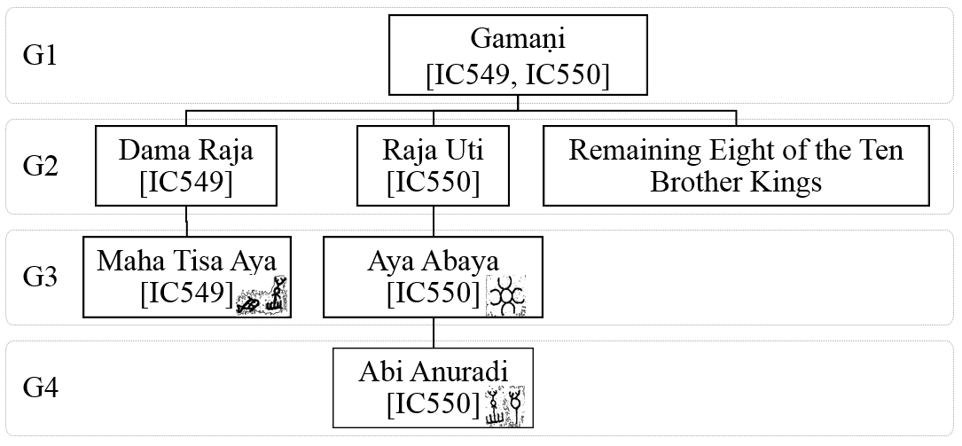
Figure 2: Royal members from the IC549 and IC550 inscriptions.
Generation 2
As shown in the Figure 2, King “Dama” and king “Ūti” are of the second generation. Further, the Table 4, another son of King "Dama" appears as Prince "Asali" in the inscription IC13. Though, written in mirrored order, the IC56 mentions King "Dama".
Table 4: Evidence on King “ Gāmaṇi Dama”
Index | IC13: “Mihintale”
Inscription
Brahmi sound | “Gāmaṇi Dhama Rajasa putasa Aya Asalisa lene”
English meaning | ‘Cave of the Prince “Asali” the son of the King”Gāmaṇi Dhama”
Index | IC56: “Mihintale”
Inscription
Brahmi sound | “Gāmaṇi Dama”
English meaning | ‘Gāmaṇi Dama….’
The first use of the royal term “Devanapiya” is appearing in the inscriptions IC47 and IC46 (see Table 5) for the King "Ūti" who is mentioned as the Great King. Further it can be noticed that the honour, “Gāmaṇi” was applied to both "Dhama" and "Ūti" Kings.
Table 5: Devanapiya Great King Gāmaṇi Ūti
Index | IC47: “Mihintale”
Inscription
Brahmi sound | “Devanapiya Maharajaha Gāmaṇi Ūti…ha Nimane”
English meaning | ‘Devanapiya Great King Gāmaṇi Ūti’s… creation’
The queens of King “Uti” are appearing in the inscriptions shown in the Table 6, first queen is Princess "Anurādi" appearing in IC338-341, which declares the offering of caves for monks by both of them while “ Ūti” was a King. The second queen of Great King “Ūti” was "Sumanā dēvi" as mentioned in IC46 in Table 6.
Table 6: King ‘Ūti’ and his Queens.
Index | IC338 (to 341): “Periya-Puliyan-Kulama”
Inscription
Brahmi sound | “Raja Naga Jita Raja Ūti jaya Abi Anurādicha raja Uti ca karapita se ima lena catudisasa sagaya agata-agatana pasu viharaye aparimita lokadathuye satana sita sukaye”
English meaning | ‘The daughter of King “Nāga”, the Queen of King “Ūti”, Princess “Anurādi” and King “Ūti” made this cave and donated for the wellbeing of Buddhist monks from four directions who have come and not come, for happiness of mind of the beings of the boundless universe’.
Index | IC46: “Mihinthale”
Inscription | 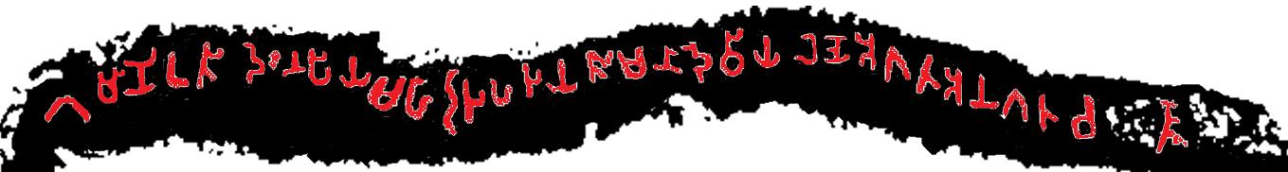
Brahmi Sound | “Gāmaṇi Ūti Devanapiya Maharaja ha jaya Sumana Deviya lene agatha anagatha ca..…”
English meaning | “Gāmaṇi Ūti Devanapiya” Great King’s queen Sumana Devi’s cave,… who have or haven’t come ….
Generation 3
Members of the third generation are the sons: Prince "Mahā Tisa” and Prince "Asali” of the King "Dama", and the daughter: Princess “Tisā” and the son: Prince “Abaya” of King "Ūti" the first "Devanapiya" great king. The King “Maha Tisa” and Prince “Asali” were mentioned already in the inscriptions IC549 (Table 3) and IC13 (Table 4) respectively. Neither the queens of the King "Mahā Tisa" nor those of Prince "Asali" are clearly appearing in the inscriptions recorded in IC. In contrast to this, the information on decedents of the King "Ūti" i.e. the “Devanapiya” family are available in the inscriptions. The daughter of King “Ūti”: princess “Tisā” appears in the inscription IC34 (Table 7).
Table 7: Princess "Tisa" the daughter of the Great King “Devanpiya Gāmaṇi Uti”.
Index | IC34: “Mihintale”
Inscription
Brahmi sound | “mātā pitasa aṭaya’’Gāmaṇi Ūti Maharajasa jita Abi Thisāya lene dasa disasa sagaye dine”
English meaning | For the benefit of mother and father, the cave of Princess “Tisa” the daughter of Great King”Gāmaṇi Ūti” is donated to Buddhist monks from all ten directions.
The son of King Ūti, Prince Abaya was already mentioned in IC550 (Table 3). There are 45 inscriptions (IC: 18, 29, 193, 672, 550, 556-569, 620, 621, 325, 836, 894, 895, 913, 963, 994, 1018-1027, 1028, 1051, 1052, 1053, 1054, 1055 and 1103) that refer to Prince "Abaya " both before and after he became the Great King. The Table 8 shows the inscriptions IC1051 located in "Tōnigala ", in “Puttalama” district in North-West of Sri Lanka. The inscription is inscribed by a chief to establish the order of the Great King "Devanapiya Gamini Abaya” to entrust two townships and the lake developed by Chief “Tisa” (Senanayake, 2017) for the benefit of Buddhist monks in a monastery called “Acha Girika Tisa” rock monastery. It is also noticeable in this inscription that, upon becoming the Great King, the prince “Abaya” too has been awarded the names of honour “Gamini” representing his lineage from king “Gamini” and the recognition as “Devanapiya” when becoming the Great King.
Table 8: The "Tonigala" inscription on Great King “Devanapiya Gamini Abaya”.
Index | IC1051: “Puttalama”
Inscription | 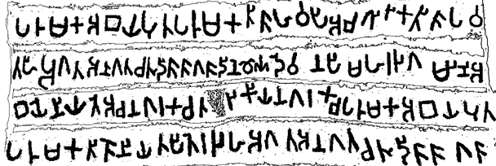1
Brahmi sound | “Parumaka Abaya puta Parumaka Tisa ha vapi Acagirika Tisa pavatahi agata anagata catu disa sagasa dine Devanapi.. Maharaja Gamini Abaye niyate Aca nagaraka ca Ta(vi)rikiya nagaraka ca Parumaka Abaya Puta Parumaka Tise niyatapite rajaha agata anagata catudisa sagasa”
English meaning | On the command of the Great King “Devanapiya Gamini Abaya”, the lake of “Parumaka Tisa”, the son of “Parumaka Abaya” is donated to the Buddhist monks who have come and not come from all four directions to the “Acagirika Tisa” rock monastery. Further, the town of “Aca” and the town of “Tavirikiya” are also dedicated to the Buddhist monks who have come and not come from all four directions by “Parumaka Tisa”, the son of “Parumaka Abaya”, establishing the King’s command.
The queen, Princess “Kana” and the wife “Kati” of prince "Abaya" are mentioned in the inscriptions IC18 in “Mihintale” and IC193 in “Kosawakanda” respectively as shown in the Table 9.
Table 9: The queen ‘Kana’ and wife ‘Kati’of Great King Devanapiya Gamini Abaya.
Index | IC18: “Mihintale, Anuradhapura”
Inscription | 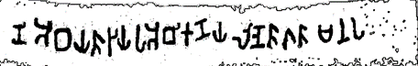
Brahmi sound | “…(Gama)ni Abayasa jayaha Abi Kanaya lene sagasa Manapa (dasane)”
English meaning | The cave named as “Manapadassane” of Princess “Kana”, the queen of …”Gāmaṇi Abaya”..
Index | IC193: “Kosawakanda”, “Anuradhapura”
Inscription
Brahmi sound | “Maharajaha Gāmaṇi Abayaha Devanapiyasa ramani bariya Milaka Tisa vihare karate Katiya”
English meaning | The “Milaka Tisa” temple developed by “Kathi” the beautiful wife of Great King “Devanapiya Gāmaṇi Abaya”.
The family tree of “Devanapiya” dynasty traced up to third generation is shown in Figure 3.
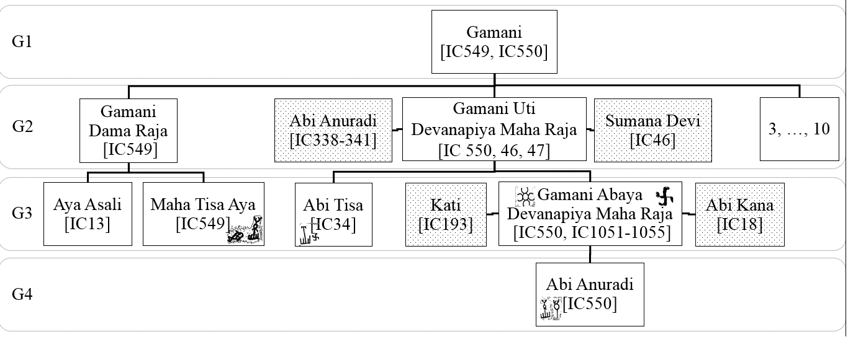
Figure 3: Second and third generation of families of Devanapiya dynasty.
Generation 4
Members of the fourth generation are the children of the King “Mahā Tisa” and the Great King “Devanapiya Gamini Abaya”. The inscriptions IC14, IC15, IC556-569 (Table 10) show that the King “Mahā Tisa” has had a daughter named “Savērā”. The inscriptions IC556 to 569 located in “Kottadämu hela” in south of Sri Lanka are on a donation of 14 caves to the Buddhist monks by Princess “Savērā” with her husband, Prince “Tisa” the son of Prince “Abaya”. This marriage shows the union of "Dama Raja" lineage with that of “Devanapiya”. The inscriptions IC14 and IC15 from “Mihinthale” in “Anuradhapura”, indicate that Princess “Savērā” has become a monk later in her life. Comparing the inscriptions IC14 and 556 (Table 10.) further reveal that the King “Mahā Tisa” was also called king “Tisa” of “Kanagama” (or “Kanagama Tisa”). Based on inscriptions, Princess “Savērā” was an only child and the inscriptions IC556-569 mark the end of the lineage from king “Dama” by connecting it with that from Great King “Devanapiya Gamini Uti”.
Table 10: Princess 'Savera' the daughter of King ‘Mahatisa’.
Index | IC556 (-569): “Koṭṭadämuhela”
Inscription | 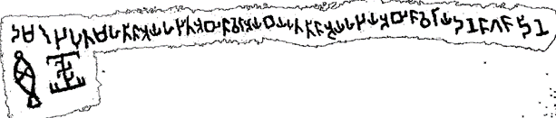
Brahmi sound | “Dama raja puta Maha Tisa ayaha jita Abi Savera Ayabaya puta Tisa ayaha jaya Abi Saveraya dane sagasa dine”
English meaning | Princess “Savera”, the daughter of prince “Maha Tisa”, the son of King “Dama” Princess “Savera”, the queen of Prince “Tisa”, the son of Prince “Abaya”, offers this donation to the Buddhist monks.
Index | IC14(-IC15): “Mihintale”
Inscription | 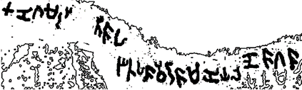1
Brahmi sound | “Kanagama Rajasa Tisaha jita Savera Samaniya lene sagasa”
English meaning | The cave of the female monk “Savērā” who is the daughter of King “Tisa” of the area “Kanagama” is donated to Buddhist monks
The children of Great King “Devanapiya Gamini Abaya” are, a daughter named “Abi Anuradi” who was already presented in Table 3, and two princes named “Siva” (Table 12) and “Tisa” who appeared in Table 7 already. The inscription IC994 shown in Table 11 mentions the name of the husband of Princess “Anuridi” as chief “Raki”.
Table 11: Princess Anuridi, Daughter of Great King Devanapiya Gamini Abaya
Index | IC994: “Sässēruwa”
Inscription | 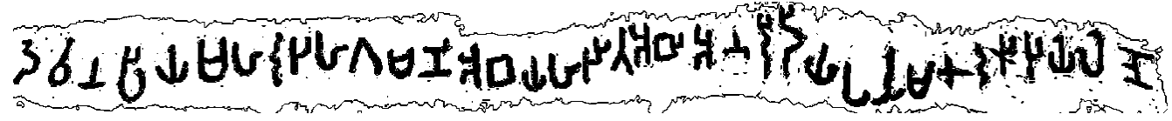
Brahmi sound | “Devanapiya Maharajaha Gāmaṇi Abayaha jita Abi Anuridiya parumaka Raki jaya lene”
English meaning | The cave (donated by) Princess “Anuridi”, the daughter of “Devanapiya” Great King “Gāmaṇi Abaya” and the wife of chief “Raki”
As per the inscription IC29 (see Table 12), prince “Siva” has been assigned to the “Lōna Wāpi” area.
Table 12: Prince “Siva”, the son of Great King “Devanapiya Gamini Abaya”
Index | IC29: “Mihintale”
Inscription | 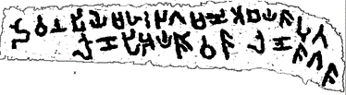
Brahmi sound | “Devanapiya Maharajaha Gāmaṇi Abayasa puta Lonapi Aya Sivasa lene sagasa”
English meaning | The cave of the son of Great King “Devanapiya Gāmaṇi Abaya”, Prince “Siva”, who is the lord of “Lona Vapi” area, is donated to the Buddhist monks.
There are 42 inscriptions that refer to Prince “Tisa” in IC, including the inscriptions in Table 10. Only the most prominent ones are quoted here. As the ten inscriptions IC1018-1027 reveal, Prince “Tisa” has donated 10 caves for the Buddhist monks in “Gallena” monastery of “Kurunegala” District before he became the great King. Changes in lettering used for “ma” and “sa” can be noticed in these. The inscription IC1028 is on the donation of a cave at the same place by his wives.
Table 13: Prince “Tisa” the son of the Great King “Devanapiya Gāmaṇi Abaya”.
Index | IC1018 (-IC1027): “Gallena” monastery, “Kurunegala”
Inscription | 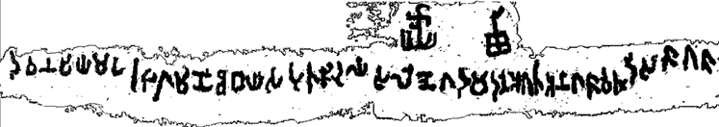
Brahmi sound | “Devanapiya Maharaja Gāmaṇi Abayasa puta Tisa ayaha lene ‘Gadamadane’ agatha anagathasa cathudisa sagasa”
English meaning | The cave named as “Gandamadana” of prince “Tisa”, the son of Great King “Devanapiya Gamini Abaya” is donated to Buddhist monks who have come and not come from all four directions.
The inscriptions IC4 and IC31 (see Table 14), reveal the names of wives of Great King “Gamini Tisa”: “Kitakā” and “Rāmadatā” respectively. It is noticeable that the inscription IC31 is later added in tiny letters to the available space above an existing inscription on a donation of the cave by a previous person as reported in IC32. This indicates that the caves were renovated at the time of the Great King “Gamini Tisa”. The queen of Great King “Gamini Tisa“, Princess “Savērā” was mentioned before in Table 10.
Table 14: The wives of the Great King “Devanapiya Gamini Tisa”
Index | IC4: “Mihintale”
Inscription | 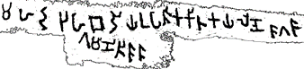
Brahmi sound | “Maharajaha Gamini Thisasa bariya upasika Kitakaya lene sagasa”
English meaning | Great King Gamini Tisa’s wife female Buddhist devotee Kitaka’s cave is donated to Buddhist monks.
Index | IC31: “Mihintale”
Inscription | 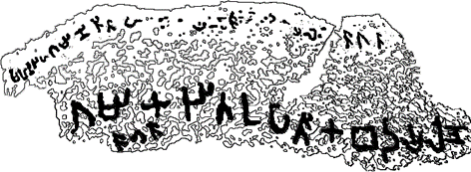
Brahmi sound | “Maharajaha Gamini Thisasa bariya upasika Ramadataya lene sagasa”
English meaning | Great King “Gamini Tisa’s wife female Buddhist devotee Ramadata’s cave is donated to Buddhist monks.
The family tree traced up to fourth generation is shown in the Figure 4 below.
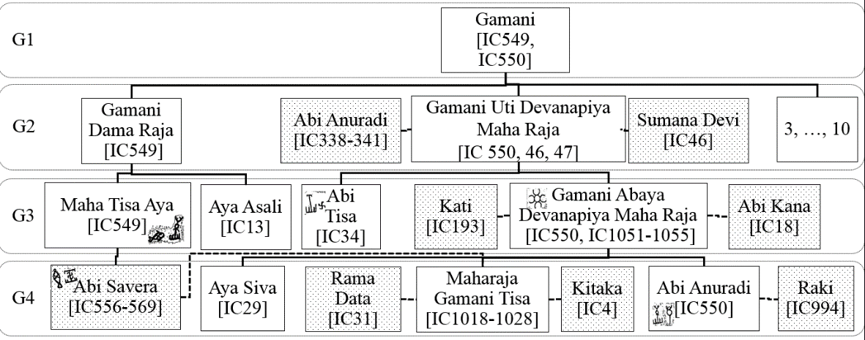
Figure 4: Devanapiya dynasty traced to the fourth generation
Generation 5
The fifth generation comprises of the children of the Great King “Devanapiya Gamini Tisa”. They are four princes namely, “Maha Aya” (Table 15), “Tisa aya” (Table 17), “Lajaka” (Table 20) and “Daraka Tisa” (Table 21). The inscriptions IC422 to IC428 found from the “Raja Gala” archaeological site in “Ampara” District in the Eastern province of the country, mention the donations to Buddhist monks by these royal personages. These inscriptions further ascertain the use of the royal names of honour: “Devanapiya Gamini” by the Prince “Tisa” after becoming the Great King.
Prince “Maha” (meaning big or the eldest) is mentioned in inscriptions IC289 and IC423 (see Table 15). According to the IC289, Prince “Maha” has had a revenue collector while his father “Tisa” was not a King, and as IC423 indicates, his father was the Great King by the time he offered caves in “Rajagala”.
Table 15: Prince 'Maha Aya' the son of Devanapiya Great King Gamini “Tisa”.
Index | C289: “Kandegama Kanda”, “Polonnaruwa”
Inscription | 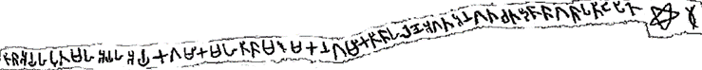
Brahmi sound | “Tisa Ayaha puta Maha Ayaha Ayaka Gamika Maha Tisa Marumakana Gamika Tisaha lene agata anagata catadisa sagasa patiṭapite”
English meaning | The cave of the grandson of the village councillor “Maha Tisa”, the village councillor “Tisa”, the revenue collector of the Prince “Maha” the son of the Prince “Tisa”, is donated for the Buddhist monks who have come and not come from all four directions
Index | IC423: “Rajagala”, “Ampara”
Inscription | 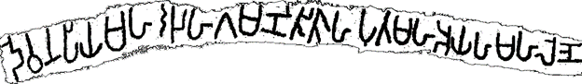
Brahmi sound | “Devanapiya Maharajaha Gamini Tisaha puta Maha Ayaha Maha lene”
English meaning | The great cave of the prince “Maha”, the son of Great King “Devanapiya Gamini Tisa”
The offering of a cave by queen “Yahasini” of Prince “Maha” is mentioned in IC422 (inscribed from right to left) while that of his second queen “Buda data” is mentioned in IC425 (see Table 16). The inscription IC89 from “Mihintale” further reveals that the queen “Yahasini” has become a monk and it is not quoted here.
Table 16: The queens of the Prince “Maha” the eldest son of Great King “Devanapiya Gamini Tisa”
Index | IC422: “Rajagala”, “Ampara”
Inscription | 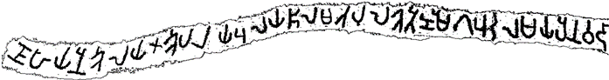
Brahmi sound | “Devanapiya Maharaja Gamini Tisaha puta Maha Ayaha jaya Upasika Yahasiniya lene.”
English meaning | The cave of the female Buddhist devotee “Yahasini”, the queen of Prince “Maha”, the son of the “Devanapiya” Great King “Gamini Tisa”
Index | IC425: “Rajagala”, “Ampara”
Inscription
Brahmi sound | “Devanapiya Maharajasa Gāmaṇi Tisasa puta Mahaya (ha jaya Upasi)ka Bu(da) Dataya lene agata anagata catudisa sagasa”
English meaning | The cave of the female Buddhist devotee “Buda Data” the queen of Prince “Maha” the son of the “Devanapiya” Great King “Gamini Tisa”, is donated to the Buddhist monks who have come and not come from all four directions.
The offerings of caves by Prince “Tisa” are recorded in IC424, IC426, IC427, IC404, IC724, IC236 and IC1110. Only the clear and prominent ones are shown in the Table 17 and in inscription IC424, the diamond shape on the script is caused by a hole, cut into the rock, possibly to insert a beam to support the roof. Further changes to lettering of “ma”, “sa” and “ja” are noticeable in these inscriptions.
Table 17: Prince “Tisa” the son of Great King “Devanapiya Gamini Tisa”.
Index | IC424: “Rajagala”, “Ampara”
Inscription | 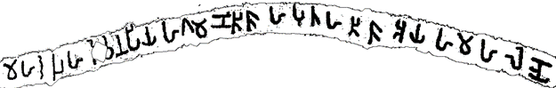
Brahmi sound | “Maharajaha Devanapiyaha Gāmaṇi Tisaha putaha Tisa Ayaha Maha lene"
English meaning | The great cave of the prince “Tisa”, the son of “Devanapiya” Great King “Gamini Tisa”..
Index | IC404: “Nuwaragala”, “Ampara”
Inscription | 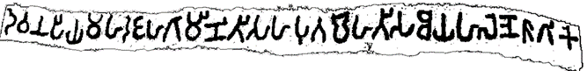
Brahmi sound | “Devanapiya Maharajaha Gamini Tisaha puta Maha Tisa Ayaha lene sagike”
English meaning | The cave of the prince “Tisa” the great, son of “Devanapiya” Great King “Gamini Tisa” is offered to the Buddhist monks
The offerings of caves for Buddhist monks by his queens, “Samika” and Princess “Jati” are mentioned in IC426 and IC427 respectively as shown in Table 18.
Table 18: The queens of Prince “Tisa” the son of Devanapiya Great King Gamini “Tisa”.
Index | IC426: “Rajagala”, “Ampara”
Inscription | 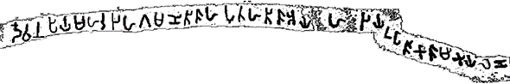
Brahmi sound | ‘Devanapiya Maharajaha Gamini Tisaha putaha Tisa Ayaha jaya upasika Samikaya lene..’
English meaning | ‘The cave of the female Buddhist devotee “Samika”, the queen of Prince “Tisa”, the son of the great King “Devanapiya Gamini Tisa”..
Index | IC427: “Rajagala”, “Ampara”
Inscription
Brahmi sound | “Devanapiya Maharajaha Gamini Tisaha putaha Tisa Ayaha jaya Abi Jatiya lene..”
English meaning | The cave developed by Princess “Jati”, the queen of Prince “Tisa”, the son of the great King “Devanapiya Gamini Tisa”..
It can be noted from the inscription IC236 from, “Andiyā Kanda” in “Riṭigala” (Table 19) that the Prince Tisa, the son of Devanapiya Great King “Gamini Tisa“ has been awarded the name “Devanapiya” upon him becoming the Great King, but he has not used the royal name “Gamini” following his father. This could have been due to having the same name as his father.
Table 19: The Great King “Devanapiya Tisa” the son of Great King “Devanapiya Gamini Tisa”.
Index | IC236: “Anḍiyā Kanda”, “Riṭigala”
Inscription | 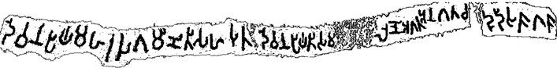
Brahmi sound | “Devanapiya Maharajaha Gamini Tisaha puta Devanapiya Tisa Ma(harajaha) lene agata anagata cadudisa sagasa”
English meaning | The cave of the Great King “Devanapiya Tisa”, the son of the “Devanapiya” Great King “Gamini Tisa” is donated to the Buddhist monks who have come and not come from four directions
According to the inscriptions IC428 the King “Lajaka” has donated twenty five ‘cool caves’ to the Buddhist monks as shown in Table 20. The inscribed letters of IC428 show a significant deviation from the letters used before.
Table 20: King “Lajaka” the third son of Great King “Devanapiya Gamini Tisa”.
Index | IC428: “Rajagala”, “Ampara”
Inscription | 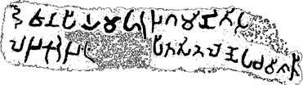
Brahmi sound | “Devanapiya Maharajaha Gamini Tisasa putha Lajaka Rajaha i(dapatiṭa)pita site lene paca visati..”
English meaning | Twenty-five cool caves were established here by the King “Lajaka” the son of Great King “Devanapiya Gamini Tisa”
The fourth son of Great King “Devanapiya Gamini Tisa”: Prince “Daraka Tisa” too have donated caves to Buddhist monks in “Maha äla gamuwa” in North Central province of the island of Sri Lanka as IC211 inscription reports (see Table 21).
Table 21: Prince “Daraka Tisa” of Great King “Gamini Tisa”.
Index | IC211: “Maha Älagamuwa”
Inscription | 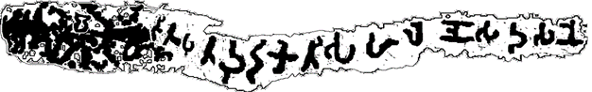
Brahmi sound | “..Gamini Tisa Maharajaha putha Daraka Tisaha lene Sudasane”
English meaning | The cave “Sudasana”, of the “Daraka Tisa”, the son of Great King “Gamini Tisa”
Generation 6
The sixth generation are the children of Prince “Maha”, “Tisa”, “Lajaka” and “Daraka Tisa”. Though there are no evidence appearing in the IC on what became of Prince “Maha”, the inscription IC75 (Table 22) shows that he had a son who took care of the “Mihintale” Lake. It can be noted that the former lettering style is used in this inscription unlike his cousins.
Table 22: Son of Prince “Maha”.
Index | IC75: Bund of the “Mihintale” lake
Inscription
Brahmi sound | “Mahayaha puta ha arake”
English meaning | protected by the son of the prince ‘Maha’
Evidence on children of King “Devanapiya Tisa” and “Lajaka” appear not to have recorded in IC, which may need further investigations in the country. Prince "Dāraka Tisa" appear to have had two sons named: “Kumāra” and “Uti” as mentioned in the inscriptions IC575 and IC378 in Table 23.
Table 23: Children of Prince “Daraka Tisa”.
Index | IC575: “Koṭṭadämūhela”, “Hambantoṭa”
Inscription
Brahmi sound | "Daraka Tisa putasa Kumarasa.."
English meaning | .. of “Kumara”, the son of “Daraka Tisa”
Index | IC378: “Nācciyārmalai”
Inscription | 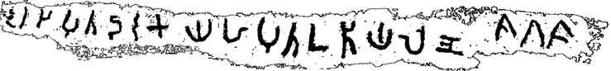
Brahmi sound | “….Raja puta Dārakayaha puta Utiya lene sagasa”
English meaning | The cave developed by “Uti”, the son of Prince “Daraka”, the son of the King…is donated to Buddhist monks.
The inscriptions on the royal lineage extending after this point is not recorded in IC, possibly due to their time exceeding the first century CE. Thus the six generations of royal members traced from the early Brahmi inscriptions of those who have embraced the royal name “Devanapiya” are illustrated as shown in the Figure 5.
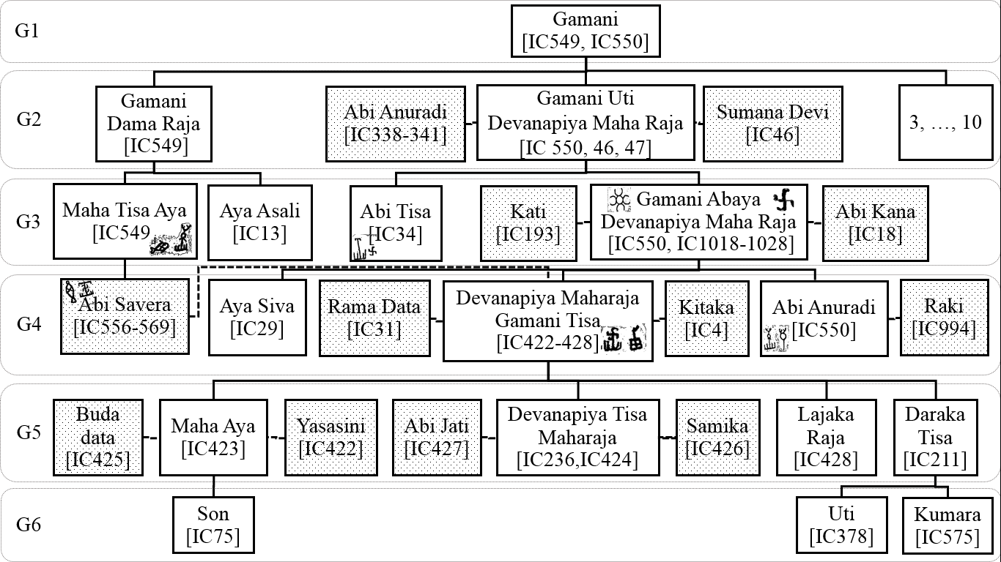
Figure 5: Six generations of royal families traced from the Inscriptions of Ceylon Vol. 1

Analysis and Discussion
The first volume of Inscriptions of Ceylon (IC) by Prof. S. Paranavithana provides a wealth of evidence on history of this island. The exhaustive number of inscriptions in IC and the locations from where the inscriptions were found indicate the efforts made by researchers in bringing these inscriptions to the attention of general public.
Since, the inscriptions are on offerings made to Buddhist monks, they were inscribed at the point of the event. The personal names mentioned in inscriptions appear to be their formal names. It appears as a practice to mention the family members when making such offerings. This was very useful to find the ancient social connections. However, not all these names of Kings appear in the palm leaf literature while, the timing and the order of the kings are also different. There have been studies made previously on the family connections of Devanapiya Kings yet, their work have been driven by the information from ‘“Mahawansa”’ affecting the placement of successive members (Gunawardhana, 1982), (Perera, 2001).
According to the inscriptions, the first King in Sri Lanka to use the “Devanapiya” adjective is Great King “Devanapiya Gāmaṇi Uti”. His father was a King “Gāmaṇi” and for six generations the Great Kings have been the descendants of this King. At the fifth Generation the name of honour “Gāmaṇi” was not used possibly to show the difference as both father and son were having the same name “Tisa”. The King with a name called “Devanapiya” who appears in “Mahawansa” is believed to be the Great King ‘Devanapiya Thissa’ (Mahanama, 1912). According to this study, he is the king of the fifth generation of the “Devanapiya” dynasty.
It can be observed that in three occasions the first son of the royal family does not become the great king. “King Uti” is not the eldest of his family, yet he becomes the Great King with the “Devanapiya Gāmaṇi” title. The destiny of King “Dama” the eldest is not clear. Based on inscriptions King “Uti” has only one son “Abaya”, who becomes the “Devanapiya” Great King”Gāmaṇi Abaya”. His eldest son prince Siva does not become the Great King but few inscriptions indicate of him becoming a monk and this needs to be further investigated. The second son, “Tisa” becomes the Great King “Devanapiya Gāmaṇi Tisa”. Whose first son, Prince “Maha” does not become the great king, while the second son “Tisa” becomes the Great King “Devanapiya Tisa”. Inscriptions reveal that queen of prince “Maha” had become a monk, and the destiny of prince “Maha” is yet to be explored. Do these evidence indicate of a royal custom that offered the first prince to the benefit of Buddhism and the second prince to the throne? is an interesting research question for further study.
Prof. Paranavitana mentions in IC Vol. 1 that Princess “Savera” whose name appears in the inscriptions shown in the Table 10, is same as princess “Vihara Maha Devi” mentioned in the “Mahawansa” (Paranavithana, 1970). According to the “Mahawansa” (Mahanama, 1912), Princess “Vihara Maha Devi” is the mother of King “Dutu Gämunu”. Prof. Pranavithana mentions in IC vol.1 that King “Dutu Gämunu” is the same person as “Great King Devanapiya Gāmaṇi Abaya” who appears in the inscriptions in Table 8, Table 9, Table 11, Table 12 and Table 13. However, according to the information revealed by the fourteen inscriptions IC556 to 569 in Table 10, princess “Savera” is the daughter in law of “Great King Devanapiya Gāmaṇi Abaya”. Therefore, princess “Savera” and princess “Vihara Maha Devi” could be two different persons, and thereby the king “Dutu Gämunu” and the “Great King Devanpiya Gāmaṇi Abaya” in IC Vol.1 could also be different persons. It is worthy of note, that there are inscriptions with the name “Dutu Gämunu”, appearing in the inscriptions of later centuries, that are recorded in the IC vol II (Paranavitana, 1983). Some of the names of the ten commanders of the King “Dutu Gämunu” of “Mahawansa” are also found in the inscriptions of IC Vol. I, as the commanders of the Great King “Devanpiya Gāmaṇi Abaya”. These inscriptions are being further studied and will be presented in a future article.
Previous research suggest that Brahmi letters found in Sri Lanka could be as old as 5th century BCE (Falk, 2014) (Deraniyagala, 2007) . Here, it is observed that the symbols of letters have not changed untill the time of Great King “Devanapiya Gāmaṇi Tisa” of the fourth generation. In the inscriptions of the Grate King and his wives, the new symbols appear first for ‘ma’ and ‘sa’ sounds. Then these appear again only in those of his son “Tisa” and his younger brothers “Lajaka” and “Daraka Tisa”. A new letter for ‘ja’ is appearing in the era of Great King “Devanapiya Tisa” as shown in the Table 24.
Table 24: Substitution of new letters after the fourth generation
Sound | Before 4th Generation | 4th Generation | 5th Generation
‘ma’
‘sa’
‘ja’
This appear to indicate close connections between Great King “Devanapiya Gāmaṇi Tisa” with influential personages from a neighbouring culture. Interestingly, on the same premises of IC422 to IC428 in “Rajagala” there is an inscription IC468 that mentions the tomb of the great Buddhist monk ‘Arahat Mahinda’ (See Table 25) in which also the new lettering symbol for ‘ma’ appear. These connections of letters are indicative of the interventions possibly from India, at that time.
Table 25: The inscription in Arahath Mahinda's tomb in Rajagala, Ampara.
Index | IC468: “Rajagala, Ampara”
Inscription | 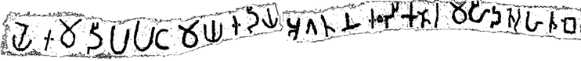
Brahmi sound | “Ye ima dipaya paṭamaya idiya agatana iḍika tera Mahida teraha tūbe”
English meaning | This is the tomb of the first monk who arrived by utmost good fortune to this island, the “Mahinda Thero”.
The close association between the Great King “Devanapiya Tisa” and the “Mahinda Thero”, is also mentioned in the “Mahawansa”. Counting back from this point of history, this study shows that there have been four generations of Great Kings who were endowed with “Devanapiya” name before the arrival of “Arahath Mahinda”. Further, the letters appearing first in the inscriptions of ‘Devanapiya Gāmaṇi Thissa’ and the ‘Devanapiya Thissa’, are also appearing in the inscriptions by Emperor Ashoka (Allen, 2012; Prinsep, 1838). These findings further suggest changes to the timing of Brahmi letters (Paranavithana, 1970) which is an important avenue for further study.

Conclusion
Study of these ancient inscriptions was of substantial interest as the connections of royal families before re-introducing Buddhism to the country could be revealed and many interesting avenues for future research also emerged. As per the “Mahawansa”, Buddhism was first introduced to the island by the “Buddha” himself by visiting the island in three occasions and many local rulers were converted to Buddhism. The findings of this study also ascertains this; that the local kings have had high regard for Buddhism and the monks even before the arrival of great Thero “Arahat Mahinda”. The great kings of the island were called “Devanapiya” and it was interesting to find that in three occasions the second prince was made the Great King and, not the eldest prince. This evidence and the destiny of the eldest princes needs to be further investigated through inscriptions and contextual studies. Regarding the inscribed lettering, same set of lettering appear to have used for the inscriptions over the first five generations and the changes appear in the eras of the Great Kings “Devanapiya Gāmaṇi Tisa” and his son, “Devanapiya Tisa” which is indicative of the time of the arrival of “Arahat Mahinda”. The inscriptions by the descendants of the “Devanapiya” dynasty could be available in the later volumes of IC waiting to be traced. Though the findings from this study does not connect directly with the information in “Mahāwansa”, it helps to understand the life in this island before the arrival of “Arahat Mahinda” and shows interesting avenues for future research. However still, the evidence on the early beginnings of the island that relate to the stories in first chapters of the “Mahawansa” are not clearly traceable from the inscriptions in the IC vol.1 and hence, an important research gap for study. On a final note, the findings of this study ascertains that the relationships in past between Sri Lanka and India were strong and beneficial for people of both countries just as today.
Declaration of Interest Statement
The authors declare that they have no conflict of interests.

References
Allen, C. (2012). 'Ashoka' The search for the India's Lost Emperor. Abacus.
Brodie, A. O. (1853). Rock inscription at "Gooroo Godde Wihare" in the "Magool Korale" of Seven "Korale". Journal of the Ceylon Branch of the royal Asiatic Society, 50-54.
Buddhagosha. (1996). Samantha Pasadika. (S. Gamalath, & W. E. A, Eds.) Colombo: Godage.
Buddhaputhra, M. (2004). Pujawaliya. (K. Gnanawimala, Ed.) Colombo: Gunasena.
Deraniyagala, S. U. (2007). Pre history and proto history of Sri Lanka. Colombo, Sri Lanka: Central cultural fund.
Falk, H. (2014). Owners graffiti on pottery from Tissamaharama. Journal for Archaeology of Non-European Cultures, 6, 45–94.
Gunasekara, B. (1900). Rajaavaliya: A historical narrative of Sinhalese Kings from Vijaya to Wimaladharmasuriya II (1 ed.). (B. Gunasekara, Ed.) Colombo: GJA Skeen, Government Printer, Ceylon.
Gunawardhana, R. A. (1982). Prelude to the state - An early phase of the evolution of political institutions in ancient Sri Lanka (Vol. 8). Peradeniya, Sri Lanka: The Sri Lanka journal of the humanities.
Hitzsch, E. (1925). Inscriptions of Asoka (New edition ed.).
Knanananda, P. (1927). Dipawamsa. Colombo: Buddhist Cultural Centre.
Mahanama. (1912). The 'Mahawamsa' or the great chronicle of Ceylon. Translated from pali to english. (W. Geiger, & M. H. Bode, Eds.) London: The Pali text society.
Muller, E. (1883). Ancient inscriptions in Ceylon, text and plates. London: Trubner and Co. Ludgate Hill.
Paranavitana, S. (1983). Inscriptions of Ceylon (Vol. II). (S. Karunaratne, Ed.) Colombo: The Department of Archaeology Sri Lanka.
Paranavithana, S. (1970). Inscriptions of Ceylon (Vol. I). Colombo: Archaeology Department Ceylon.
Perera, L. S. (2001). The institutions of ancient ceylon from inscriptions, Vol.1 from 3rd Century BC to 830 AD . London: Self published.
Prinsep, J. (1838). On the edicts of Piyadasi, or Asoka, the Buddhist monarch of India, preserved in the Girnar rock rock in the Gujerat peninsula, and on the Dhauli Rock in Cuttak; with discovery of Ptolemy's name there in. Journal of the Royal Asiatic Society, 219-282.
Saloman, R. (1998). Indian Epigraphy. New York: Oxford University Press.
Samaranayake, D. P. (1959). Sulu Rajavaliya. (D. P. Samaranayake, Ed.) Colombo: Colombo Free Press.
Senanayake, A. M. (2017). A Study on social identity based on the Brahmi inscriptions of the early historic period in the North Western province, Sri Lanka. Social affairs-A journal for social sciences, 33-43.
Somadeva, R. (Prof. RALH Gunawardane felicitation volume,). Prelude to the state: further thinking on the formation of early political institutions of early Sri Lanka. (H. Dheeraananda, & R. Dasanayake, Eds.) Colombo: Godage.
Vedehathera. (2001). Samanthakuta Warnnana. (Paknnaloka, Ed.) Deniyaya.

